Customer management issues data in to the database mysql server
Working Screenshots of SQL Project :
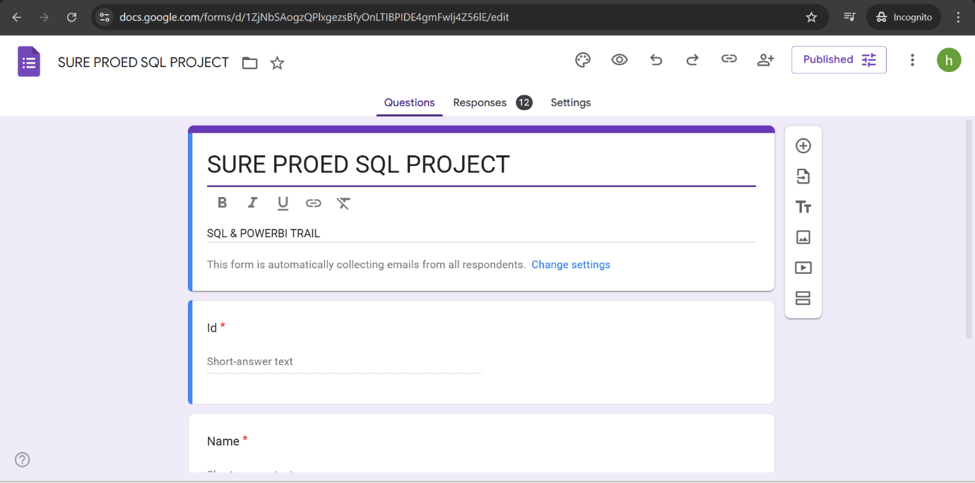
Fig 1: Created a Google Form for taking User responses

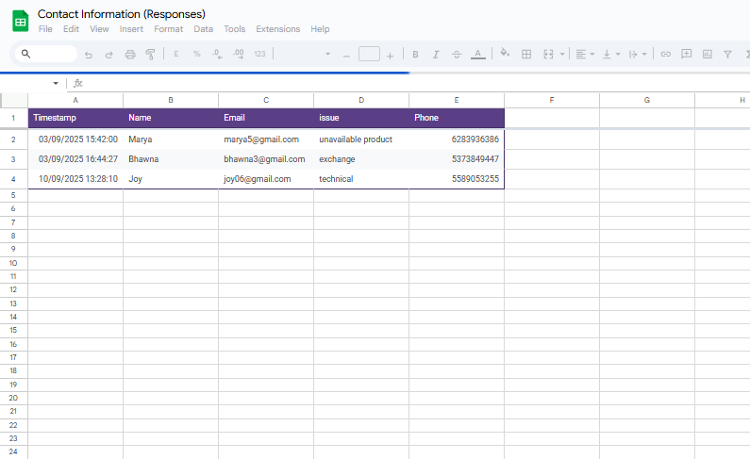Fig 2 : The responses are directly stored into a Spreadsheet

Fig 3 : The workflow created in Pabbly Connect from Google Sheets to MySQL Workbench

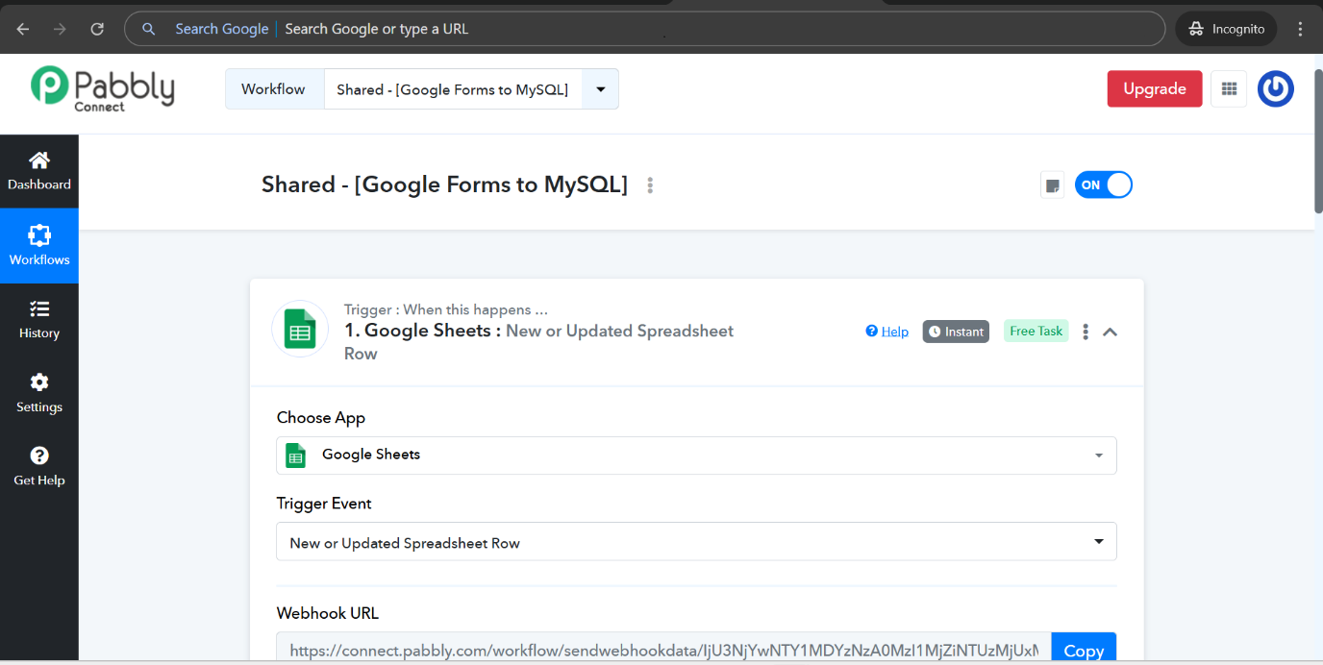
Fig 4 : Google sheets responses being triggered into Pabbly Connect

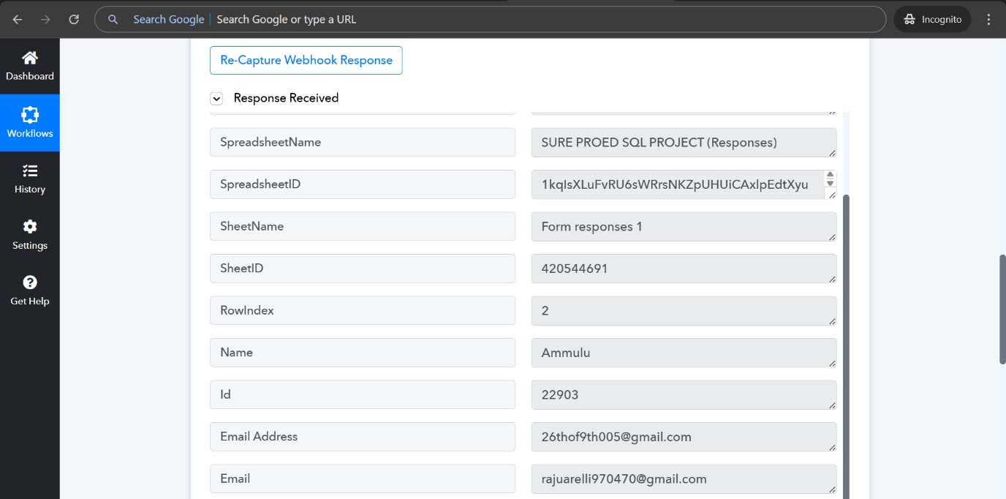
Fig 5 : The response received from the sheets to Pabbly Connect

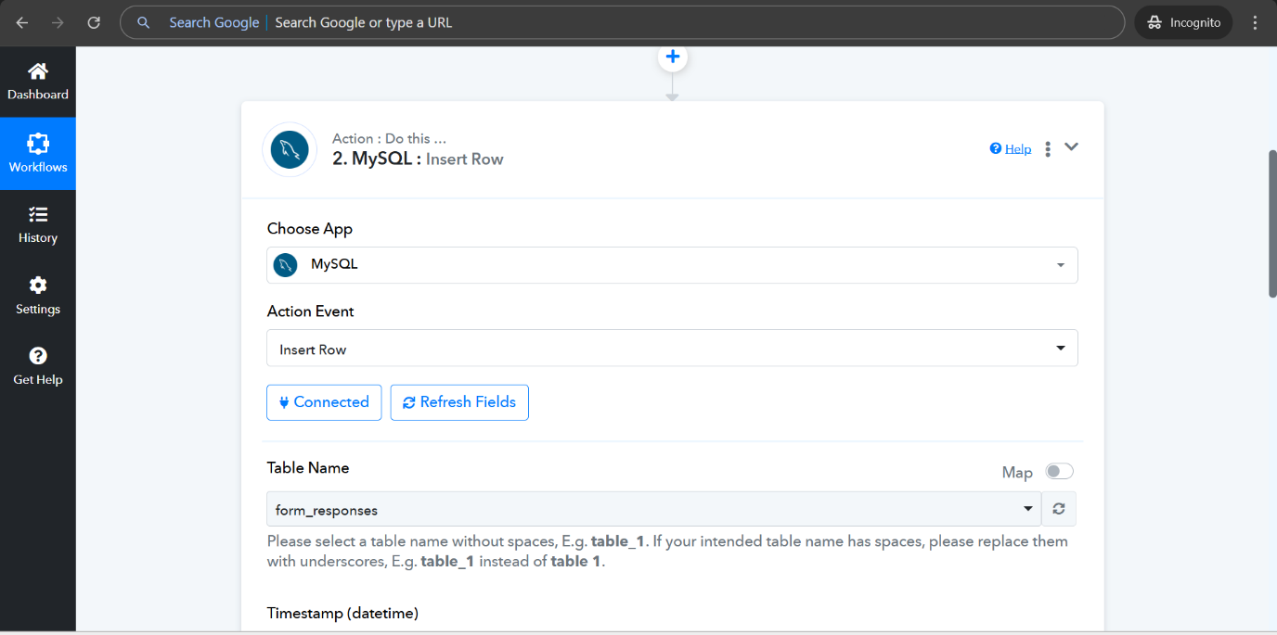
Fig 6.1 : Connecting Pabbly to MySQL workbench

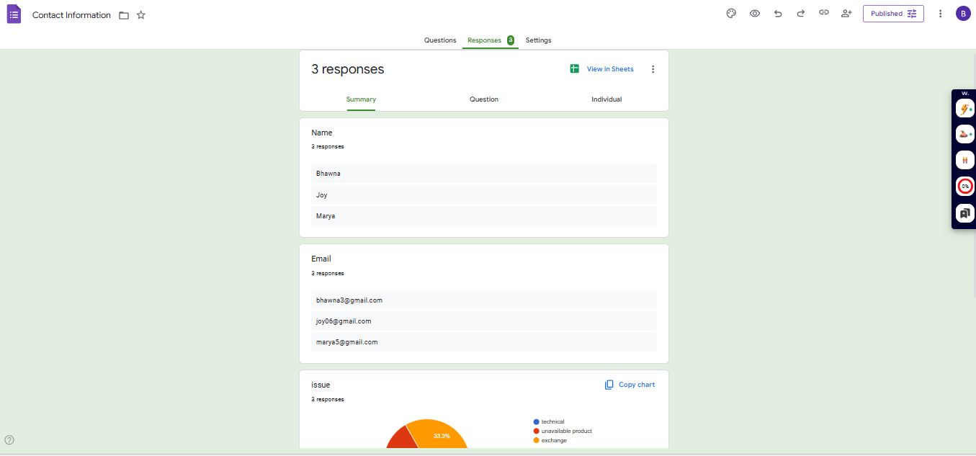
Fig 6 .2 : Data being sent from Pabbly to MySQL

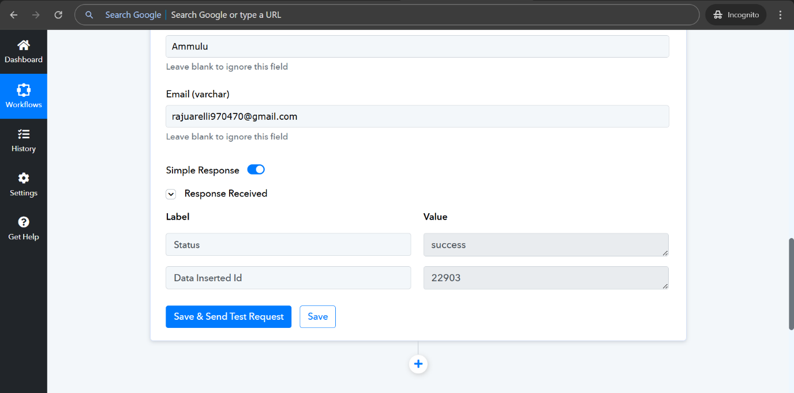
Fig 7 : Message indicating successful insertion into the MySQL

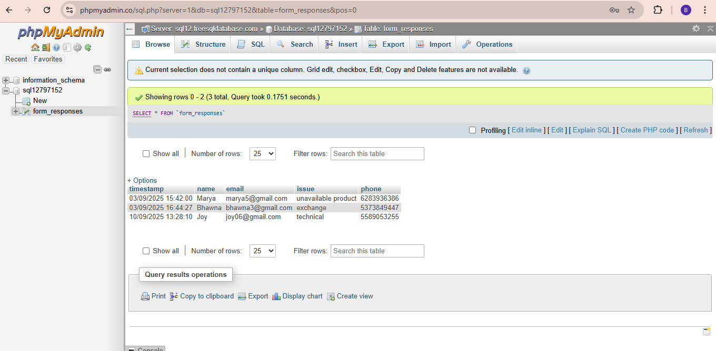
Fig 8 : Data stored in My SQL Workbench

